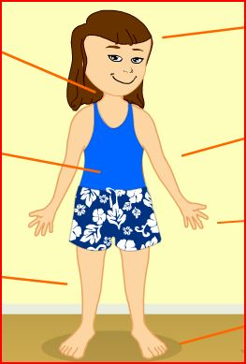**A letter to a new e-pal**

**Me & My Body Reading Comprehension**

(A) Read the text:

 Dear friend,

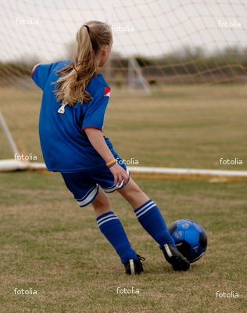My name is Dana. I am 9 years old and I live in Nicosia, Cyprus. I want to describe myself so you know what I look like.

I am not very tall and not very short. I have long, curly hair. It is brown. I have green eyes. My face is round. I love to play football and  computer games with my friends from school.

The name of my best friend is Johanna. She is 9 1/2 years old. She also lives in Nicosia. She is very tall! She has long, straight hair. Her hair is blond and she has blue eyes. Her face is long – oval shape. Her legs are also very long!

We have another friend. His name is Ben. He is also 9 years old. He is a little short. He has short, black and straight hair. His eyes are black. His face is the shape of a triangle.

We always play with them. We love to be together every afternoon after we do our homework.

Please tell me about you and your friends too!

                                                            Yours, Dana.

   (B) Answer:

                  1.      Dana is – 

                  2. Johanna is – 

                  3. Ben is – 

                  4. Match the shape and color of the hair –

                  (a) Dana's hair is  ,  and  .

                  (b) Johanna's hair is  ,  and  .

                  (c ) Ben's hair is  ,  and 

5. The color of the eyes -

                 (a) Dana's eyes are 

                  (b) Johanna's eyes are 

                  (c ) Ben's eyes are 

                  6. Faces –

(a) Dana has a  face.

                  (b) Johanna has a  face.

                  (c ) Ben has a  face.

                 7. Who has long legs? 

(C) Fill in the correct form of the verb:

1. Dana  curly hair.

2. Dana  green eyes.

3. Johanna and Ben  her friends.

4. Johanna and Dana  long hair.

5. Ben  short hair.

6. Ben and Johanna  straight hair.

7. Johanna's face and legs  long.

8. Johanna  tall.

9. Ben short.

10. His face  the shape of a triangle.

(D) Describe yourself:

My hair is  and  .

I am  my legs are  .

My eyes are  .

The shape of my face is  .